**Assignment 10.2:**

**Implement the concept given in below blog link and share the complete steps along with screenshots.**

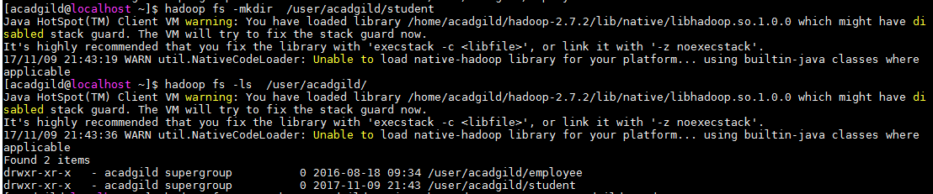

Moving the given data set to hdfs

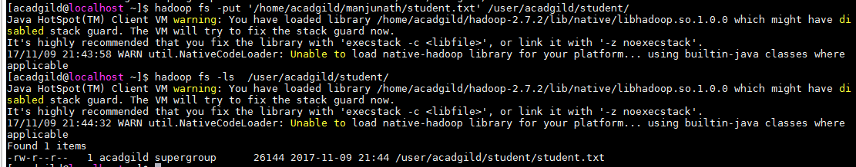

Listing the Dataset file

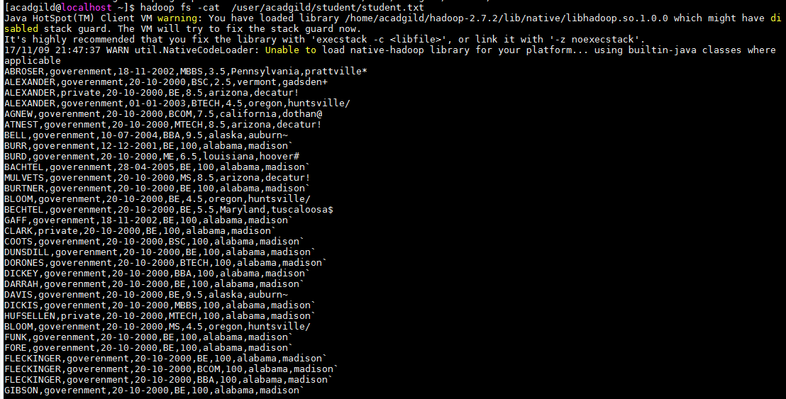

set Pig classpath.



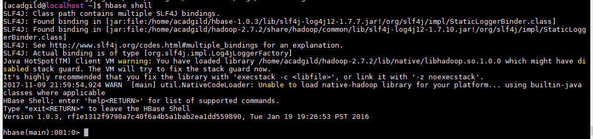

Logged into HBase shell and created the table studentAcad

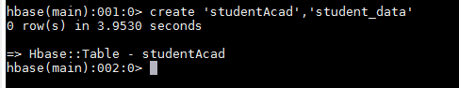

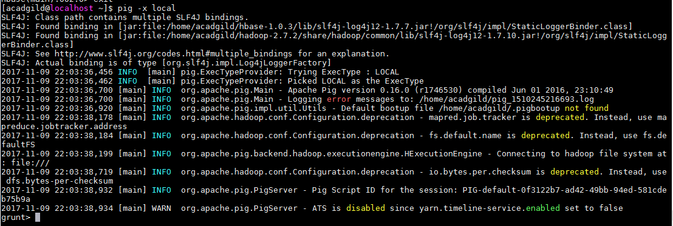

Data loaded into pig

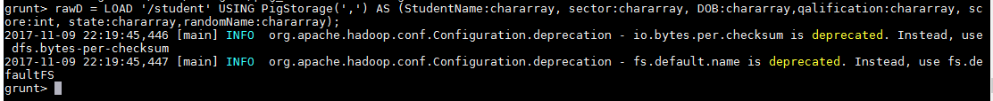

Moving the data into the HBase (i tried many times, but it’s not storing properly)

